Contestant Number: ____________________
Time: ___________________
Rank: _______________



Managerial Accounting
(135)

NATIONAL 2024

CONCEPT KNOWLEDGE:

Multiple Choice (10 @ 2 points each) ________________ (20 points)
APPLICATION KNOWLEDGE:
Short Answer (11 @ 3 points each) ________________ (33 points)
Problem 1: Capital Investments ________________ (35 points)
Problem 2: Flexible Budgets ________________ (64 points)

TOTAL POINTS ________________ (152 points)

Test Time: 90 minutes

GENERAL GUIDELINES:
Failure to adhere to any of the following rules will result in disqualification:
- Member must hand in this test booklet and all printouts if any. Failure to do so will result in disqualification.
- No equipment, supplies, or materials other than those specified for this event are allowed in the testing area. No previous BPA tests and/or sample tests (handwritten, photocopied, or keyed) are allowed in the testing area.
- Electronic devices will be monitored according to ACT standards.
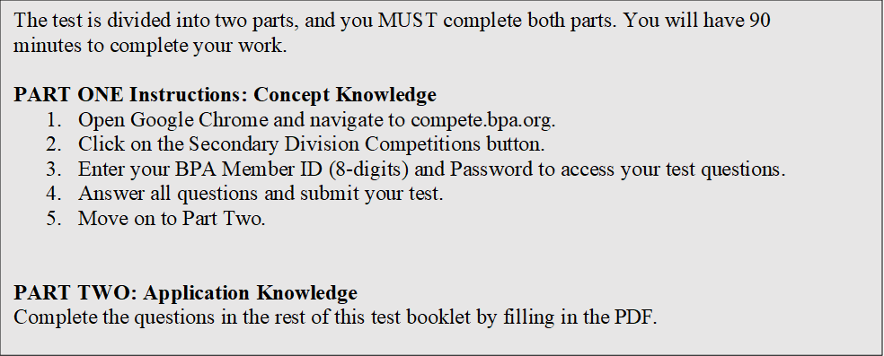
EXAM GUIDELINES:

You have been hired as a Financial Assistant and will be keeping the accounting records for Digital Solutions, located at 700 Morse Road, Suite 201, Columbus, Ohio 43214. Digital Solutions provides accounting and other financial services for clients. You will complete jobs for Digital Solutions’ own accounting records, as well as for clients.

You will have 90 minutes to complete your work. The test is divided into two parts: concept knowledge and application knowledge.

Your name and/or school name should not appear on any work you submit for grading. Write your Member ID in the provided space. Staple all pages in order before you turn in your test.

Assumptions to make when taking this assessment:
- Round all calculations to two decimals at the final step.
- Round all percentages to one decimal place.
- Use 360 days for interest calculations.

Short Answer

1. Berenger Productions uses a standard cost system for recording transactions. Berenger reported the following data for the year ended December 31:
- Sales revenues: $550,000
- Cost of goods sold (standard costing): $382,500
- Selling & administrative expenses: $80,000

Variances:

Sales revenue variance | $4300 | F
Direct materials cost variance | 10 | U
Direct materials efficiency variance | 250 | F
Direct labor cost variance | 70 | U
Direct labor efficiency variance | 10 | F
Variable overhead cost variance | 300 | U
Variable overhead efficiency variance | 80 | F
Fixed overhead cost variance | 420 | U
Fixed overhead volume variance | 130 | F

What is the net operating income on a standard cost income statement?

2. Vaughn Company is a price-taker and uses target pricing. Refer to the following information:

Production volume | 602,000 units per year
Market price | $30 per unit
Desired operating income | 17% of total assets
Total assets | $13,800,000
Variable cost per unit | $18 per unit
Fixed cost per year | $5,400,000 per year

With the current cost structure, Vaughn cannot achieve its profit goals. Vaughn has determined that the variable costs cannot be reduced. Assume all units produced are sold.

What are the target fixed costs per year?

3. Dorn Inc. is a price-setter that uses the cost-plus pricing approach for pricing its products. These products are unique, artistically designed architectural decorations. Dorn produces and sells 6100 units per year, which represent maximum capacity. Variable costs are $300 per unit. Total fixed costs are $910,000 per year. The CEO has a target of $50,000 in operating income, which he wants to achieve by year-end.

Using the cost-plus pricing method, what sales price per unit should Dorn charge?

4. The income statement for Cerrano Company is divided by its two product lines, golf club covers and golf ball markers, as follows:

 | Covers | Markers | Total
Sales revenue | $820,000 | $320,000 | $1,140,000
Variable costs | 365,000 | 260,000 | 625,000
Contribution margin | 455,000 | 60,000 | 515,000
Fixed costs | 66,000 | 106,000 | 172,000
Operating income (loss) | $389,000 | $( 46,000) | $343,000

Cerrano estimates that it can eliminate total fixed costs of $32,000 by dropping the golf ball markers line.

If Cerrano drops the markers line, will operating income increase or decrease?
If Cerrano drops the markers line, how much will operating income increase/decrease by?

5. Basic Light Bulb Company manufactures light bulbs. The standard direct materials quantity required to produce one LED light bulb is one half pound at a cost of $2 per pound. During November, 7,000 LED light bulbs were produced using 4,200 pounds of direct materials that cost $7,350.

What is the direct materials cost variance? Indicate the amount and if the variances are favorable (F) or unfavorable (U).
What is the direct materials efficiency variance? Indicate the amount and if the variances are favorable (F) or unfavorable (U).

6. The following labor standards have been established for a particular product:

Standard labor-hours per unit of output | 10.3 hours
Standard labor rate | $ 15.70 per hour

The following data pertain to operations concerning the product for the last month:

Actual hours worked | 8700 hours
Actual total labor cost | $ 133,893
Actual output | 860 units

What is the direct labor rate variance? Indicate the amount and if the variances are favorable (F) or unfavorable (U).
What is the direct labor efficiency variance? Indicate the amount and if the variances are favorable (F) or unfavorable (U).

7. Phelps Corporation makes a product with the following standard costs:

 | Standard Quantity | Standard Rate | Standard Cost per Unit
Direct materials | 6.9 pounds | $ 7.40 | $ 51.06
Direct labor | 0.4 hours | $ 28.00 | $ 11.20
Variable overhead | 0.4 hours | $ 4.40 | $ 1.76

In June the company's budgeted production was 3800 units but the actual production was 3900 units. The company used 22,550 pounds of the direct material and 2330 direct labor-hours to produce this output. During the month, the company purchased 25,800 pounds of the direct material at a cost of $174,180. The actual direct labor cost was $57,421 and the actual variable overhead cost was $10,718.

The company applies variable overhead on the basis of direct labor-hours. The direct materials purchases variance is computed when the materials are purchased.

What is the variable overhead rate variance? Indicate the amount and if the variances are favorable (F) or unfavorable (U).
What is the variable overhead efficiency variance? Indicate the amount and if the variances are favorable (F) or unfavorable (U).

Problem 1: Capital Investment Decisions (35 Points)

Hayes Mfg. is considering two different pieces of specialized equipment for their manufacturing process. Depreciation is calculated using the straight-line method. Hayes has an 5% expected rate of return. The expected net cash inflows from the investment are given below:

 | Equipment A | Equipment B
Cost | $590,000 | $610,000
Useful life | 5 years | 5 years
Residual Value | $65,000 | $75,000
Annual Cash Flows:
Year 1 | $209,000 | $140,000
2 | 151,000 | 140,000
3 | 164,000 | 140,000
4 | 99,000 | 140,000
5 | 77,000 | 140,000

 | Equipment A | Equipment B
Payback Period
Net Present Value
Profitability Index
Which investment should be accepted?

Problem 2: Flexible Budgeting (64 Points)

The L. Brown Theatre is a nonprofit organization devoted to staging plays for children. The theater has a very small full-time professional administrative staff. Through an arrangement with the actors’ union, the actors and directors rehearse without pay and are only paid for actual performances.

The L. Brown Theatre had tentatively planned to put on six different productions with a total of 108 performances. Some of the costs vary with the number of productions, some with the number of performances, and some are fixed and depend on neither the number of productions nor the number of performances. The costs of scenery, costumes, props, and advertising vary with the number of productions, but not performances. The wages of actors, directors, stagehands, ticket booth personnel, and ushers vary with the number of performances, as well as the cost of renting the theater and printing the programs. Administrative expenses are more difficult to analyze, but it is estimated that approximately 75% of the budgeted costs are fixed, 15% depend on the number of productions, and the remaining 10% depend on the number of performances.

After the beginning of the year, the board of directors authorized expanding the theater’s program to stage seven productions and a total of 168 performances. Not surprisingly, actual costs were much higher than the planning budget (grants from donors and ticket sales were also higher, but are not shown here). Actual costs appear below.

L. Brown Theatre
Year End December 31, 20XX
Static Budget |  |  | Actual Costs
Budgeted Number of Productions | 6 |  | Actual Number of Productions | 7
Budgeted Number of Performances | 108 |  | Actual Number of Performances | 168
Actors’ and directors’ wages | $216,000 |  | Actors’ and directors’ wages | $341,800
Stagehands wages | 32,400 |  | Stagehands wages | 49,700
Ticket booth personnel & ushers wages | 16,200 |  | Ticket booth personnel & ushers wages | 25,900
Scenery, costumes, & props | 108,000 |  | Scenery, costumes, & props | 130,600
Theater hall rent | 54,000 |  | Theater hall rent | 78,000
Printed programs | 27,000 |  | Printed programs | 38,300
Advertising | 12,000 |  | Advertising | 15,100
Administrative expenses | 43,200 |  | Administrative expenses | 47,500
Total | $508,800 |  | Total | $726,900

Prepare a flexible budget report for the year that shows both spending and activity variances.

 | Actual Results | Spending Variances | Flexible Budget | Activity Variances | Static Budget
Actor & director wages | $341,800 |  |  |  | $216,000
Stagehand wages | 49,700 |  |  |  | 32,400
Ticket booth & usher wages | 25,900 |  |  |  | 16,200
Scenery, costumes & props | 130,600 |  |  |  | 108,000
Theatre hall rent | 78,000 |  |  |  | 54,000
Printed programs | 38,300 |  |  |  | 27,000
Advertising | 15,100 |  |  |  | 12,000
Administrative Wages | 47,500 |  |  |  | 43,200

